HEART in Haiti School Story
On January 12, 2010, an earthquake struck Haiti leveling many of the buildings and killing over 300,000 people. After the earthquake Schadrac St. Louis, a Haitian immigrant from New York, flew to Haiti to help his people. Shad’s background is in education. He holds a master’s degree in School Counseling. During his time in Haiti, he connected with people, like Jonathan Nash Glynn of Long Island NY and Dick Martin of Atlanta GA, who helped him acquire land for a school and build the school in Croix-du-Bouquet.
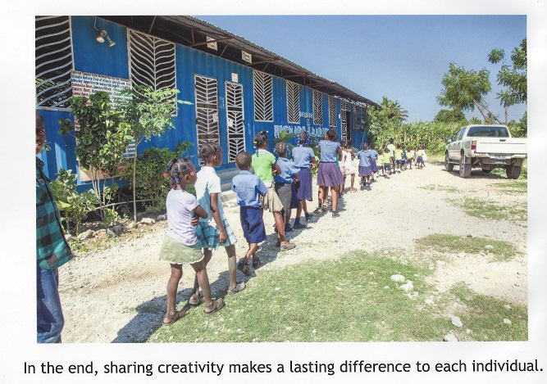
Dick Martin, retired professor from Georgia Tech’s Architecture Department (now College of Design), had had students study how to use retired shipping containers to build homes, schools and offices. Through the Midtown Atlanta Rotary Club, Dick was able to raise over $25,000 to purchase 4 shipping containers, have them moved to the school property, and to hire Haitian construction workers. He supervised the construction, consulting with the Haitians, who built the concrete pilings, cut the doors and windows for the building and welded the 4 containers together.

Figure 1 Richard L Martin Building at the HEART School
The school has now been operating for 7 years. It started with pre-K and kindergarten in 2010 and has added a grade a year since 2010. In the Fall of 2017 the school is beginning 7th grade (high school in Haiti), which requires a major investment in teachers and classrooms. Midtown Atlanta Rotary Club has been and continues to be a major funder of scholarships through the Buddy Program, among other projects at the school. Other donors are Rotary Clubs - Blagoengrad Bulgaria, Nashville, and Northwest Westchester - and Foundations – The Rose Foundation of Haiti, ArtReach, Solar Cities, Willem Philippi, and Public Private Alliance – and Churches and Businesses.
Many Rotary friends and family members also contribute to the HEART in Haiti School. Some sponsor as many as 10 or 12 Buddies or a musical instrument project or a basketball court. We are grateful for continued support from our many Buddy Sponsors and welcome new Buddies.
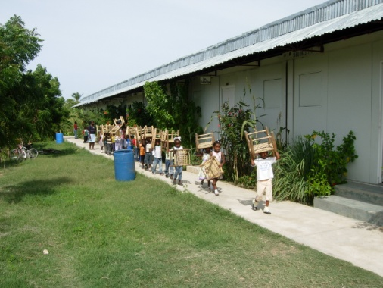
Donors have provided modules leftover from hotel construction to use as classrooms, office and library. The Rose Foundation of Haiti has provided a roof to cover the modules so they don’t leak and created a multipurpose building for school and community activities. Midtown Atlanta Rotary built a basketball court. Nashville Rotary Trust provided desks and chairs and funding for the wall around the school. NY Rotary donated a propane stove for the cafeteria, so the cooks in the cafeteria didn’t have to cook over charcoal (a health hazard). ArtReach held teacher training sessions to teach the teachers how to help the children who experienced trauma and life-threatening circumstances. Solar Cities helped build a biodigester system to provide propane from food and crop waste for the kitchen to use for cooking and to eventually sell to the community.
Figure 2 Modular building classrooms, library and offices with children and their chairs
This school is the result of Midtown Atlanta Rotary believing that Haiti can rebuild and become a successful nation. The other organizations have followed our lead knowing they could count on the success of this school. We all are working to make this school sustainable as well as create a model to be used all over Haiti.
In the early days of the school, the families couldn’t fund much of the operation of the school, but as the economy has improved and more family members have found work, they are able to make small contributions to the school to share the cost of the operations. They feel a strong sense of ownership of this school, which has earned an excellent reputation for teaching its students and developing its teachers.
You can help our school by contributing to our Buddy Program. The Buddy Program is a scholarship for the children. Our scholarship for elementary school children is $365 per year. Our scholarship for high school is $500 per year. These scholarships cover school operations, teachers’ and administrators’ salaries; breakfast and lunch and a snack each school day for the children; maintenance of the grounds, buildings, and equipment (generator and truck). Even if you can’t completely fund a scholarship any size contribution helps us operate the school another year.
Please help the school fund another year of operation and make an investment in the future of Haiti. Be a Buddy and send your check, marked for HEART, to Tom Quinn, Midtown Atlanta Rotary Foundation, c/o Ansley Golf Club, 196 Montgomery Ferry Drive NE, Atlanta, GA 30306.

If you have interest in visiting the school, we have work opportunities and projects that you can help with. Contact Sandy Murray sandy_murray@yahoo.com or Barbara Rose ngpinc5@comcast.net for more information or to schedule a trip.

Thank you for your continued support for this school. Visit us on the web at www.heartinhaiti.org.

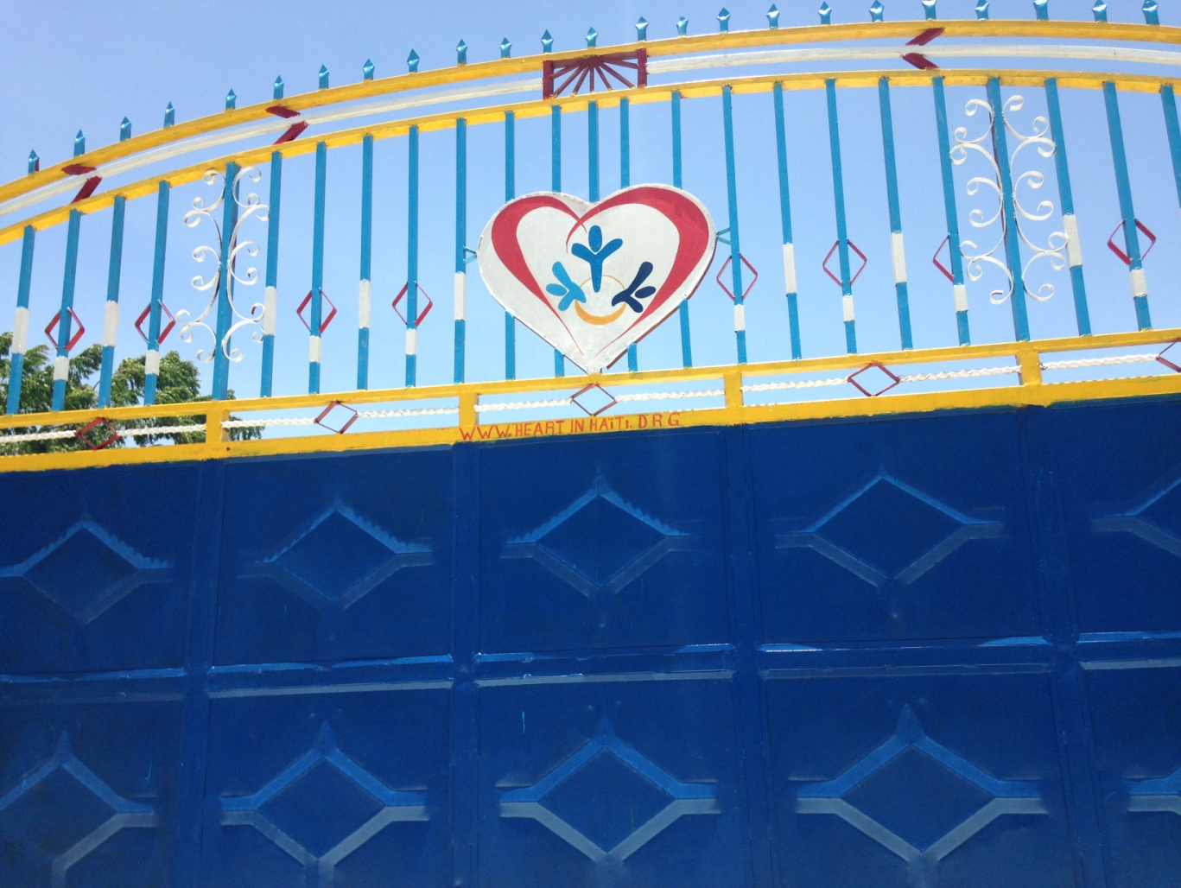
Figure 3 HEART in Haiti Gate - paid for by Midtown Atlanta

