
Editor: Sandy Murray  Sandy_murray@yahoo.com  404-273-0906 | The Midtown Messenger  January 31, 2016

  Club Information  Meets at Ansley Golf Club  196 Montgomery Ferry Rd  Tuesday at 12:30 PM  Charter Date  Founded in April 1956  Useful Links  Our Home Page  Our Directory  Rotary International  Haiti Project  Club Leaders | Meeting This Week  Al Blackwelder, Leading a discussion on race relationships  Please notify Myron Martin if you cannot perform your duties.  Upcoming Programs and Events  Star Student Breakfast Volunteers  One of our favorite events of the Rotary year is the STAR Student/Teacher Breakfast. We need you to be hosts for our guests. Plan to arrive at 7 AM February 21st so you can greet the STARS and their families.  National Wear Red Day Is February 3rd  The American Heart Association is asking people to wear red on February 3rd to help raise awareness about heart disease and how to prevent it. In the US heart disease and stroke cause 1 in 3 deaths among women each year.   Celebrate January Birthdays  Birthdays
    
    Albert Kay Blackwelder
    President
    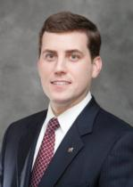
    Elmer Stancil Jr.
    President Elect
  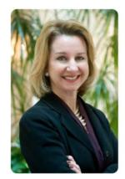 | Courtnay Bazemore  Secretary
   | Paul Lundy  Treasurer
   | Julie B. Goldberg  Past President
    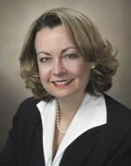
  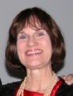 | Sandra Murray  Club Communications Chair
  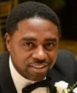 | Juan McGruder  Rotary Foundation Chair
   | William L. Burns III  Sergeant-at-Arms
  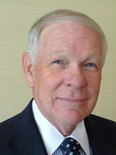 | T. Myron Martin  Sergeant-at-Arms
   | Thomas Worthy  Director at Large
   | Brian McGuire  Club Programs Chair
  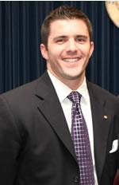 | Ryan Jacobs  Membership Chair
  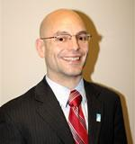 | Dolph Goldenburg  Service Projects
  Meeting Duties This Week
  Date |  | Pledge and Invocation |  | Guests |  | Greeter/  Attendance
  1/31 |  | Carol Gray |  | Matt Harper |  | Andrew Isenhour
  2/7 |  | Ryan Jacobs |  | Jonathan Johnson |  | Susan Kanellos
  2/14 |  | Glenn Kellum |  | Dennis Larry |  | Paul Lundy
  2/21 |  | Myron Martin |  | Sophie Mason |  | Joey Maxwell
  Date | Speaker
  2/7 | Dr Kirby Godsey, Chancellor, Mercer University
  2/14 | Happy Valentines Day!  Gretchen Corbin, Commissioner, Technical College System of Georgia and Scholarship Presentation
  2/21 | STAR Student/Teacher Breakfast!!!!
  2/28 | Club Service Projects Information Session
   | Member | Birthdate
  1 | David Moreland | January 2
  2 | Bettina Cothran | January 21
  3 | Matt Harper | January 25
  4 | Susan Kanellos | January 25
  5 | Barry Nickelsberg | January 31

